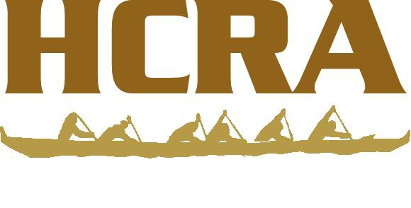

Within 7 days of an incident, send completed Insurance Incident Reporting forms to:

Kainoa Scheer kscheer@acwhawaii.com
ACW Group, LLC
Insurance, Bonding & Employer Solutions
1000 Bishop Street, Suite 600 |Honolulu, Hawaii 96813
Tel: (808) 535-5076 | Fax: (808) 535-5055 | Mobile: (808) 392-2056 | www.acwgroup.com

Copy: Keri Mehling (kerionmaui@yahoo.com)

Be sure to include information for the contact person at the Canoe Club that is submitting the report!

Include the waiver for the person(s) injured.

Include the crew list with phone numbers for the crew members & each witness statement.

If an escort boat is involved, include the escort boat waiver and contact information.

